Shelton Public Library
OPEN HOUSE
November 29th, 2022
1:00-7:00 p.m.
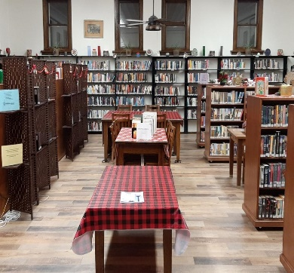 | 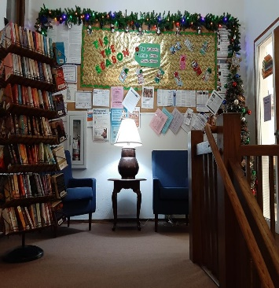 | 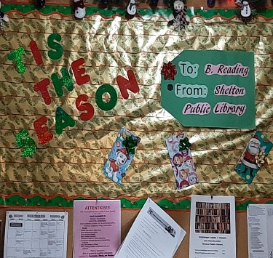

Check out the new floors!
With your donations, and the support of the Arthur Klinkacek Community Enrichment Fund of the Kearney Area Community Foundation, our library was able to get new floors this year!
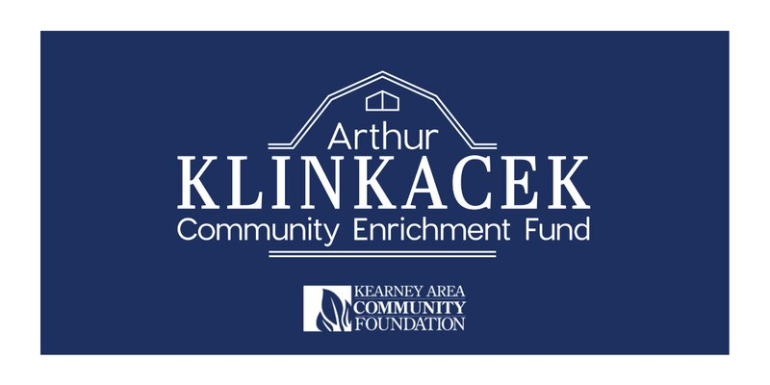

Stop in to see the new look of the library by attending our OPEN HOUSE
on November 29th, 2022 from 1 p.m. to 7 p.m.
Serving the community of Shelton for 108 years!
Together we can do great things!

Support your local library by joining the Friends of Shelton Public Library!

